Operation
This chapter provides personnel instructions on carrying out operating modes.

  - Safety instructions
DANGER!
Falling materials
The materials to be processed may fall at any time. Risk of cuts from flying splinters and materials, or splinters and materials left lying around.
This could lead to severe or even fatal injury. – Shut down the machine and prevent it from
restarting before entering the safety area.
- Allow the machine to run empty before starting work in the machine area.
- Regularly remove residues of material for pro‐ cessing and fragments from the whole machine area.
- Do not remain in the immediate vicinity of materials to be processed.
- Wear safety goggles in the machine area.
DANGER!
Suspended loads
Falling loads may lead to serious or fatal injury.
- Secure suspended loads.
- Do not work under suspended loads.
- Never swing loads above personnel.

WARNING!
Remaining in the safety areas
During machine operation, there is a risk of injury if personnel remain within the closed protective device and the safety areas monitored by safety light barriers.
This could result in death or serious injury.
- Stop the machine before entering the safety area.
- Only approach the machine via marked and identi‐ fied passages.
- During operation, maintain a distance of 1 m from conveyors, moving parts, light barriers and protec‐ tive paneling.
- Only enter safety areas at places intended for this purpose.
- Do not climb over protective devices.
- Do not remove protective devices.
WARNING!
Impermissible operating pressure
Lacerations and bruised caused by bursting machine parts conducting compressed air. This could cause serious injury or even death.
– The operating pressure may not exceed 6 bar.
WARNING!
Residual energy when the machine is switched off
Even when the machine is switched off, there is danger of injury due to residual energy.
This could cause severe and even fatal injury.
If there are faults, components do not always return to their final position. As a result, components con‐ tain residual energy in the form of potential energy. When the fault is rectified, the residual energy can be released by the components moving uncontrollably.
– Secure and de-energize the machine before car‐ rying out any work on the machine.

  - Safety equipment

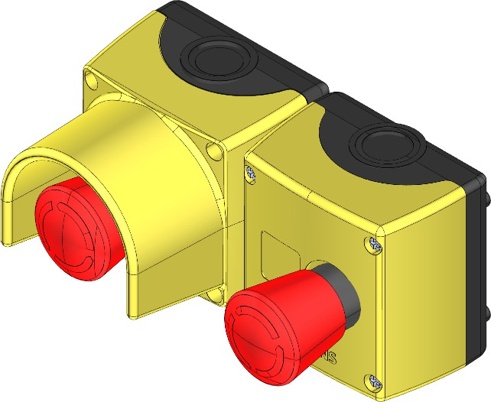
    - Emergency stop switch Function
NOTICE!
Improper use of the emergency stop switch
Never use the emergency stop switch to switch off the machine in normal operation.
This may result in damage to the machine or to items in the surrounding area.
- Only use the emergency stop switch in case of emergency.
- In normal operation, end production and switch off the machine as described in the chapter entitled “Operation”.

Figure 82: Examples of emergency stop switches
Use an emergency stop switch to turn the machine off immediately in hazardous situations.
Pressing the emergency stop switch Personnel:  Operating personnel
Prerequisite:
A hazardous situation has occurred.  Press the emergency stop switch.
      - The machine stops immediately. The operator console dis‐
plays a message.

Unlocking the emergency stop switch Personnel:  Operating personnel
Prerequisite:
The hazardous situation has been eliminated.

WARNING!
Improper unlocking of the emergency stop switch
Unlocking the [emergency stop switch] presents a risk if the reason for the [emergency stop switch] being actuated is not clarified and rectified.
This could result in death or serious injury.
- Determine why the [emergency stop switch] was actuated.
- Rectify the emergency situation using the instruc‐ tions in the chapter entitled “Faults”.
- Before unlocking the [emergency stop switch] and switching the machine back on, make sure that there is no-one present in the hazardous areas of the machine.
- Turn the emergency stop switch on the operator console to unlock it.
- Pull the emergency stop switch on the machine to unlock it.

Switching the system back on again after an emergency stop using the emergency stop switch
Personnel:  Operating personnel Prerequisites:
  - An emergency stop switch has been pressed.
  - An emergency machine stop has been triggered.
- Check and correct the cause of the emergency stop; see chapter “Faults”.
- Ensure that nobody is in the safety area of the machine.
- Unlock the activated emergency stop switch.
- Acknowledge the messages on the operator console; see chapter “Layout and function” , section “Operator console”.
  - If the machine control system is able to reset all of the mes‐ sages triggered by the emergency stop switch, the machine is enabled for switching on.

    - Safety doors
Restarting after emergency stop by means of the safety door

Personnel:  Operating personnel Requirements:
- A safety door was opened.
- An emergency stop has occurred.
- Check and eliminate the cause, see the “Faults” chapter.
- Make sure that there are no persons in a secured area of the machine.
- Close the opened safety door.
- Prepare the machine for operation; see section “Preparing for operation”.
- Acknowledge the fault on the actuation housing for the safety door, see section “Operating controls”.
- If the [Stop after end of cycle] button on the actuation housing for the safety door is not pressed before opening the safety door, acknowledge the message on the operator console for the machine; see chapter “Layout and function” , section “Operator console”.
  - The machine is released for startup.
- Continue production; see section “Production”.

  - Signaling equipment
    - Signal lamp
The signal light displays the operating status of the machine using visual signals.
Assignment of colors to operating statuses:

Color | Signal | Machine status
Red | Steady light | The emergency stop is actuated.
Red | Flashing | A guard door is open.
Yellow | Steady light | Material defect; machine con‐ tinues production.
Yellow | Flashing | Material defect; machine stops.
White | Steady light | The machine is in operation.
White | Flashing | Machine has stopped; automatic restart is active.
Green | Steady light | Machine is switched on and ready for production.

Color | Signal | Machine status
 | Flashing | Machine is switched on and ready for service operations.
Blue | Steady light | Fault; operator intervention required.
Blue | Flashing | Fault ready to be acknowledged.

    - Signal horn Pressure drop
In the operating status [Off], parts of the pneumatic system may be pressurized. While the machine is in the operating status [Off], the machine may lose pressure in the pressurized parts of the pneumatic system. If the pressure in the monitored parts becomes low enough that the material for processing can no longer be held securely, then the audible signal indicates the pressure drop.
DANGER!
Falling retaining pressure with suspended load
During an emergency stop, part of the pneumatic system continues to be supplied with pressure. This part of the pneumatic system is monitored by sensors and holds suspended loads in position. If the sensors report a pressure drop, then an audible warning signal sounds.
Falling loads may lead to serious or fatal injury.
- Ensure that the noise level in the vicinity of the machine allows audible warning signals to be heard.
- Do not stand underneath the suspended load when correcting faults in the vicinity of the suspended load.
- Immediately leave the area of the machine when the audible warning signal sounds.

Start-up warning
If the machine is in the operating status [On] and the [Start] button is pressed, then the signal horn gives an audible signal to indicate the machine is starting up. There is a delay between the audible signal and the start-up.

Fault
If the machine control system recognizes a fault or a triggered safety device, then the machine switches from operating status [On] to oper‐ ating status [Off]. The signal horn gives an audible signal to indicate the change in the machine's operating status.

  - Operating controls
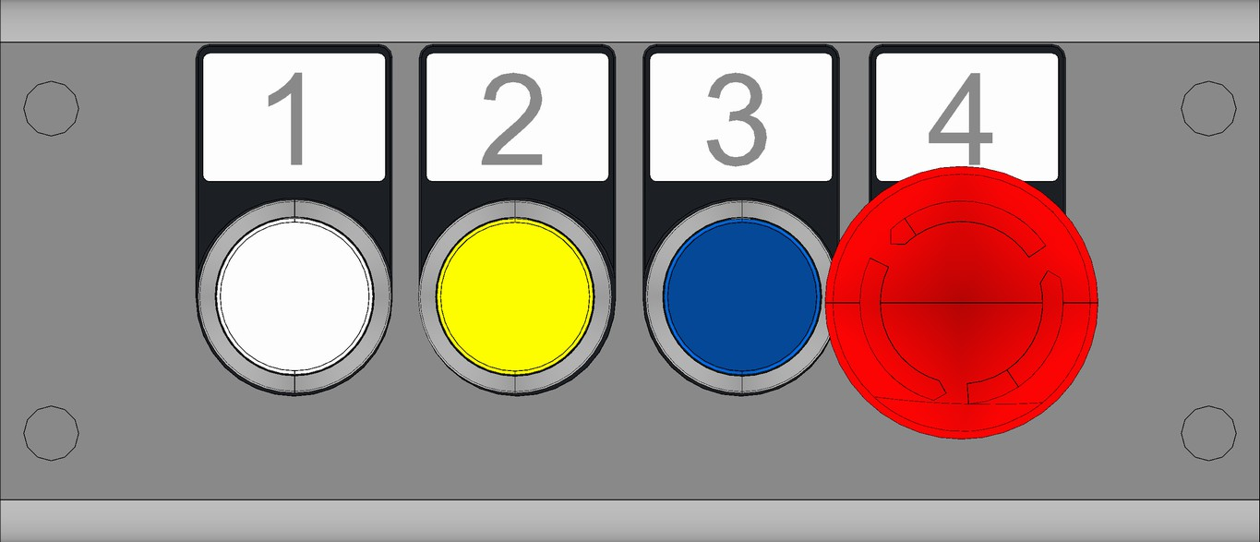
    - Actuation housing Actuation housing for safety door

Figure 83: Actuation housing for safety door

Item | Function | Name | Meaning
1 | [Start/stop] illu‐ minated push button | Machine start/ stop | Steady light: Machine on
2 | [Stop after cycle end] illu‐ minated push button | Stop after end of cycle | Steady light: Machine is in the "Stop" operating status  Flashing light: Request to change machine to "Stop" operating status
3 | [Acknowledge] illuminated push button | Acknowledge safety door | Steady light: Safety door open  Flashing light: Acknowl‐ edge safety door
4 | [Emergency stop switch] | Emergency stop | Trigger emergency stop
Entering the secured area

Personnel:  Operating personnel
- Press the [Stop after cycle end] button.
  - The [Stop after cycle end] button flashes and the machine moves to a defined position.
Once the machine has reached the defined position, the button stops flashing and illuminates permanently.
- Open the safety door and enter the secured area.

Continuing production after the safety doors have been opened Personnel:  Operating personnel
Requirement:
There is nobody in the secured area.
- Close the safety doors.
- Press the [Acknowledge] button.
- Press the [Start/stop] button.
  - The machine resumes production.

    - Main switch Layout






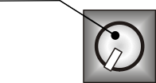
1

Figure 84: Switch cabinet main switch
1 Main switch

Function
The main switch controls the power supply to the machine and switch cabinets.
There are bores in the switch to prevent a restart. Attaching a padlock prevents the switch from being turned.
Switching on

Personnel:  Operating personnel

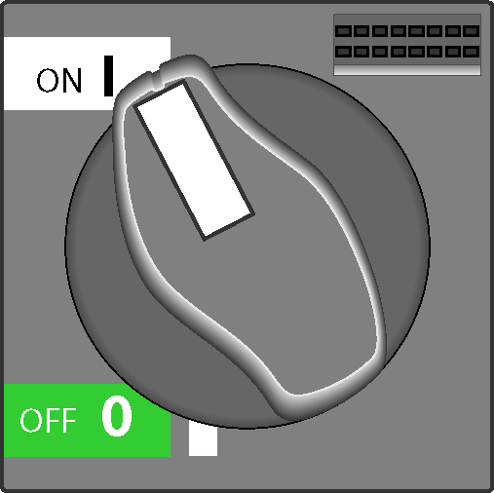
Set[Main switch] to the (ON I) position.
- The power supply is switched on.

Switching off and securing
Personnel:  Operating personnel

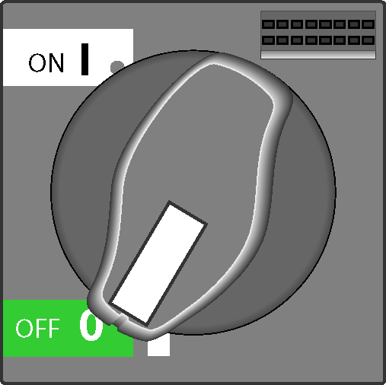
- Set the [Main switch] to the (OFF 0) position.
  - The power supply is switched off.
- Insert a padlock through the bore holes and lock it. All persons who enter the secured area attach their own padlock.
  - The machine is secured against unintentional restarts.

    - Main valve Layout
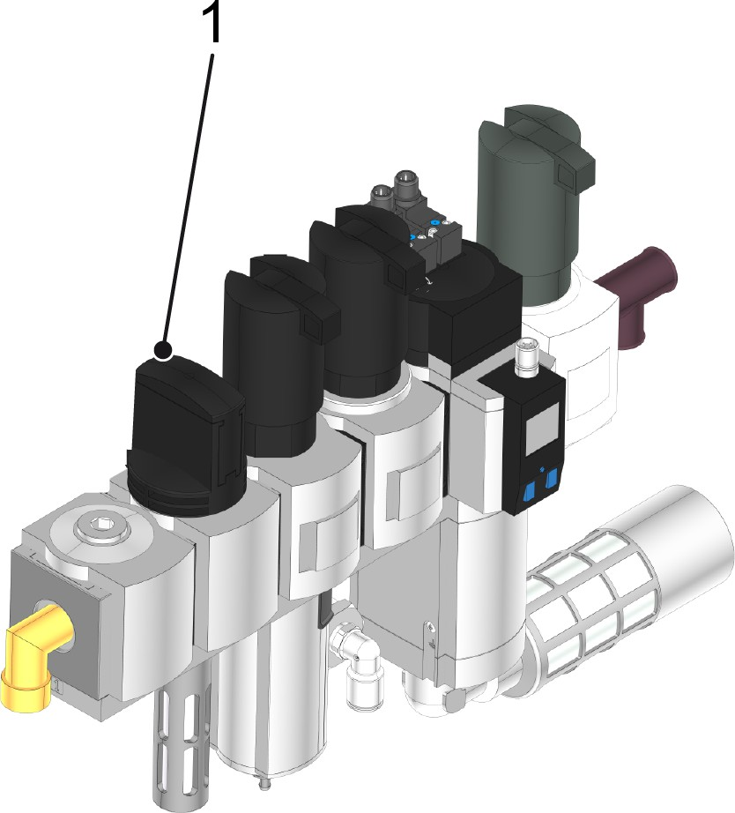

Figure 85: Main valve on the maintenance unit
1 Main valve

Function
The main valve controls the compressed air supply to the machine.

There are bore holes in the valve switch to prevent a restart. Attaching a padlock prevents the valve switch from being turned.
Opening the compressed air supply Personnel:  Operating personnel
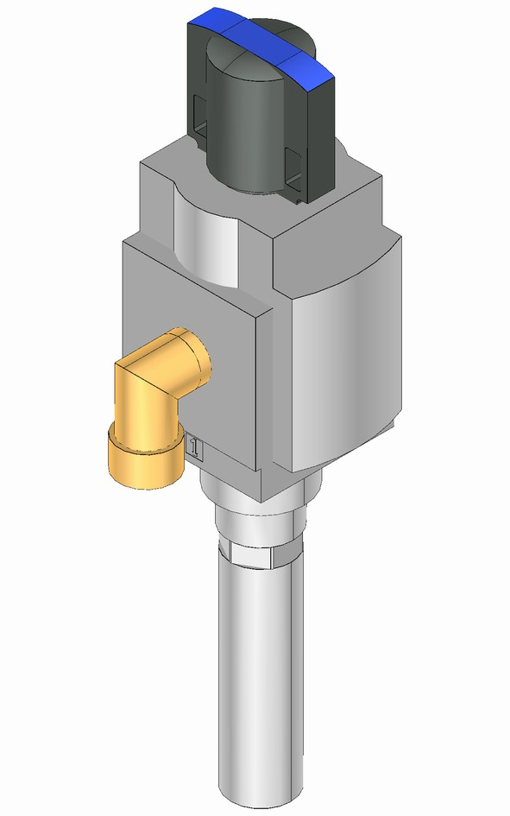
Open the [main valve] by turning the valve switch.
- The compressed air supply is open.

Closing and securing the compressed air supply Personnel:  Operating personnel
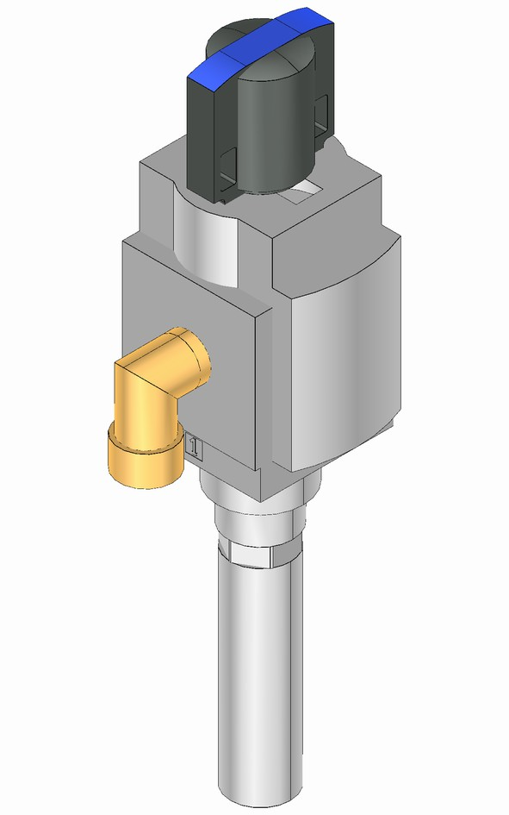
- Close the [main valve] by turning the valve switch.
  - The compressed air supply is closed.
- Insert a padlock through the bore holes and lock it. All persons who enter the secured area attach their own padlock.
  - The machine is secured against unintentional restarts.

  - Preparing for operation
DANGER!
Starting a machine that is not ready for operation could result in fatal injury!
Serious or even fatal injury to operating and mainte‐ nance personnel and/or considerable property damage could result if the machine is insufficiently or incorrectly prepared.
There is a risk of injury if safety devices are inoperable or have been rendered inoperable.
– All criteria for making the machine operational must be met before switching on the machine.

For information on the location of the operating controls, see chapter
“Layout and function”, section “Operating controls”. Personnel:  Maintenance personnel
Conditions for operation:
Assembly work is complete, see chapter “Assembly”.
- Perform maintenance work.
- Remove residual material for processing and foreign objects from the area of the machine.
- Open the main valve on the maintenance unit.
- Ensure that there is nobody in the secured area.
- Switch on the [main switch].
- Turn the [Control voltage] key switch to the [On] position.
- Rectify and acknowledge any pending fault messages.
  - The control voltage is switched on and the machine is ready for operation.

  - Production
This chapter provides personnel with instructions for carrying out pro‐ duction tasks.

    - Safety instructions
DANGER!
Falling materials
The materials to be processed may fall at any time. Risk of cuts from flying splinters and materials, or splinters and materials left lying around.
This could lead to severe or even fatal injury. – Shut down the machine and prevent it from
restarting before entering the safety area.
- Allow the machine to run empty before starting work in the machine area.
- Regularly remove residues of material for pro‐ cessing and fragments from the whole machine area.
- Do not remain in the immediate vicinity of materials to be processed.
- Wear safety goggles in the machine area.

    - Prerequisites
- The supply of material for processing required for production is guaranteed.
- It is possible to convey processed material for processing for fur‐ ther processing.
- The positioning pins are not sticking into the machine columns. The positioning pins are stored on the bracket for the positioning pins.
- The clamps for the lifting frame safeguards are not folded onto the brackets.

    - Preparation Setting up the machine
Personnel:  Operating personnel
Set up the machine for the type intended for production. See section entitled “Setup”.

    - Starting production
For the arrangement and names of the buttons on the operator con‐ sole, see chapter “Layout and function”, section “Graphical user interface”.
Personnel:  Operating personnel
Requirement:
The machine is ready for operation.
- Switch the [Operating mode] key switch to the [Automatic] posi‐ tion.
- In the “Type” menu, check that the relevant type has been selected and adjust as necessary.
- In the “Statistics” menu, check the production figures and adjust as necessary.
- Activate the “Enable crate infeed” function.
- Activate the “Enable bottle infeed” function.
- Activate the “Production” program.
- Press the [Start] button.
  - The machine starts production

    - Monitoring production
Personnel:  Operating personnel
The machine operates fully automatically. The working area and work process are monitored at the operator console.

    - Stopping the machine
Personnel:  Operating personnel
For the arrangement and description of the buttons and functions on the operator console, see chapter “Layout and function”, section “Operating controls”.
Press the “Cycle stop” button.
      - The machine moves into a defined position and stops.

    - Monitoring production stop Personnel:  Operating personnel
- Monitor stopping of the machine via the assigned operator con‐ sole. See chapter “Layout and function”, section “Operating controls”.
- Ensure that the machine is not started unintentionally.

    - Resuming production

It is easy to continue production after a controlled stop and a machine cycle stop.
Continuing after a controlled machine stop Personnel:  Operating personnel
Requirement:
- The requirements for production have been met.
- The machine is ready for production. Start production.

Continuing after a cycle stop
Personnel:  Operating personnel Start production.

Continuing after an uncontrolled machine stop Personnel:  Operating personnel
Requirement:
- The requirements for production have been met.
- The machine is ready for production.
- Pending messages are resolved.
- Messages are acknowledged. Start production.

Continuing after an emergency machine stop Personnel:  Operating personnel
Requirement:
- The steps for restarting after an emergency stop have been per‐ formed. See section “Safety equipment”.
- The requirements for production have been met.
- The machine is ready for production.
- Pending messages are resolved.
- Messages are acknowledged. Start production.

    - Ending production
Personnel:  Operating personnel
- Activate the function activation “Bypassing bottle shortage (MIN switch)” on the operator console of the machine.
  - The remaining bottles on the container conveyor upstream of the machine move onto the container table despite the shortage.
- Activate the “Crate infeed override” function on the operator console of the machine.
- Activate the “Bottle table override” function on the operator con‐ sole of the machine.
  - The remaining containers on the container table of the machine are packed despite the shortage of containers.
- Wait until all processed products have left the machine.
- Press the [Stop] button.
  - The machine stops production.
- Activate the “No program” program.

- Remove remaining processed products from the machine if nec‐ essary.

  - Cleaning
This chapter provides personnel with instructions on carrying out the cleaning process during normal production operation.

NOTICE!
Contamination
Contamination caused by irregular and improper cleaning could impair the quality of the product being processed or produced.
This may result in damage to the machine or items nearby.
- Monitor the hygienic conditions of and around the machine regularly. Clean the machine as speci‐ fied in the instructions contained in this operating manual.
- The customer/user is responsible for checking the quality of cleaning as part of its quality control process.

    - Safety instructions
WARNING!
Unauthorized machine startup
This could cause severe and even fatal injury.
- End production and stop the machine before car‐ rying out any work on the machine.
- Use your own padlock to secure the main switch against unauthorized startup.
- Secure and depressurize pneumatic components:
  - Switch off the control voltage for activating sole‐ noid valves.
  - Also, shut off the main air supply and depressu‐ rize the system.
  - Secure the air supply against unauthorized use with a padlock.

WARNING!
Accidental starting of the machine
Danger of being drawn in by moving machine parts! Danger of crushed limbs and lacerations! This could result in death or serious injury.
- Turn off the drive before carrying out any work on the machine.
- Turn off all necessary switches
- Use your own padlock to secure the main switch
at the electrical switch cabinet against unauthorized startup.
Each operator must secure the machine against inadvertent startup with his/her own padlock. This is particularly when several operators work on the machine.
- As far as possible, all work must be performed with the machine secured and deenergized.
WARNING!
Aggressive detergents
The cleaning of heavily soiled components with aggressive chemical detergents such as acids and caustics poses a health hazard.
This could result in serious or even fatal injury.
- Choose the detergents to be used carefully.
- Do not use detergents containing substances listed in the Ordinance on Hazardous Substances.
- Do not mix chemicals not intended for this purpose to avoid gases or vapors.
- Make sure that there is adequate ventilation.
- Wear suitable protective equipment such as protec‐ tive gloves and safety goggles.
- Do not eat, drink, or smoke during cleaning work.
- Point out the possible risks of using cleaning agents to operating personnel.

WARNING!
Pressurized system
Danger of injury from flying components and flowing media when opening pressurized components, tanks, and pipes.
This could cause severe and even fatal injury. – Before working on the system, depressurize
(relieve the pressure) and drain the system and
components.
CAUTION!
Emissions of hazardous substances
Dangerous chemical reactions can occur when using and mixing various chemical substances.
Gases/vapors may be produced which irritate the skin or respiratory system.
This could result in slight or minor injury.
– Heed information on cleaning agents and their han‐ dling in the manufacturer's instructions.
WARNING!
Environmental pollution resulting from improper dis‐ posal
There is a risk of polluting the environment if operating materials such as lubricants and detergents are not disposed of properly.
- Follow the instructions in the leaflets enclosed with the operating materials.
- Collect used operating materials in suitable con‐ tainers marked in accordance with regulations.
- Dispose of contaminated cleaning utensils in suit‐ able containers marked in accordance with regula‐ tions.
- Observe local disposal regulations.
NOTICE!
Improper cleaning
Improper cleaning may result in damage to the machine or the surrounding area.
- Do not use a steam jet or high-pressure washer to clean surfaces.
- Do not use compressed air to clean or dry surfaces.

NOTICE!
Improper cleaning of electrical equipment Risk of machine damage
- Never spray electrical equipment, switch or oper‐ ator panels, switch and control cabinets etc. with water.
- Never spray light barriers, inductive proximity switches, or sensors and ultrasonic sensors with water.
NOTICE!
Non-qualified personnel
May result in damage to the machine or the sur‐ rounding area.
– Only qualified personnel should perform work on the machine.

    - Specifications
Remove any contamination caused by the ongoing operation with plenty of water under low pressure and detergents. Remove the resi‐ dues of processed products with a broom.
For instructions on cleaning heavier contamination, contact KHS.
The detergents used are specified by the local hygiene representa‐ tives. When selecting the detergent, observe the following require‐ ments and the information in the purchased parts documentation.
The following should be used:
- Solutions with a pH value between 4.5 and 9
- Water under low pressure
- Water temperatures below 40°C The following should not be used:
- Detergents with chlorine, ammonia, phosphoric acid or their com‐ pounds
- Scouring detergents
- Solutions with a pH value below 4.5 or above 9
- Water under high pressure
- Water temperatures greater than 40°C

Production malfunction due to use of lubricants
Do not use anything with lubricating properties on surfaces that can come into direct contact with the product. Using lubricants on surfaces that come into contact with the product leads to production malfunc‐ tions.
Maintain requirements for water quality. For more infor‐ mation, see chapter “Technical data” section “Require‐ ments for media”.

    - Preparation
Personnel:  Operating personnel
- Ending production
  - Ensure that no products are in the machine
- Turn off the main switch on the switch cabinet and secure it against being reactivated using your own safety lock.
  - The machine is ready for cleaning. Perform activities according to section “implementation” in this chapter.

    - Execution
Personnel:  Operating personnel
Protective equipment:  Protective equipment against detergents
being used
Prerequisite:
The machine is ready for cleaning.
- Clear away contamination without damaging surfaces.
- Remove residues of materials for processing.
- Rinse solution with water under low pressure.
- Rub surfaces dry.

  - Setup
This chapter provides personnel with instructions on setting up the machine for the production of various goods.

    - Safety instructions
WARNING!
Improper setup
During setup, hazards arise due to residual risks, which may lead to accidents.
A prerequisite for correct setup is comprehensive knowledge of the machine and responsible handling of residual risks.
Severe or even fatal injury may result.
– Retooling may only be performed by trained and authorized specialists.
CAUTION!
Sharp edges on material for processing and waste from material for processing
Manual work involving sharp edges may lead to cuts. This could cause slight or minor injury.
– Wear protective gloves when carrying out any work on the material for processing.
NOTICE!
Non-qualified personnel
May result in damage to the machine or the sur‐ rounding area.
– Only qualified personnel should perform work on the machine.
NOTICE!
Use original parts from KHS
Original parts not supplied from KHS are not tested and approved. KHS will not be held liable for any damage resulting from the use of non-original parts.
– Only use original parts from KHS

NOTICE!
Operating in manual functions
Components are not blocked in relation to one another by confirmation prompts when operating in a manual function.
This leads to a risk of collisions between components.
This may result in damage to the machine or the sur‐ rounding area.
– When operating the components in a manual func‐ tion, care must be taken to ensure that the paths to be traveled are free and that components will not collide with one another.

    - Prerequisites
- Production on the machine has ended, see section “Ending pro‐ duction”.
Personnel:  Maintenance personnel
Check the secured area for residues of processing materials. If necessary, enter the secured area and remove any residual processing materials.
  - The machine is ready for setup.

    - Dimensions and settings
Dimensions and settings
The dimensions and values to be configured for a formation are indicated by markings on the machine. They can also be found in the “Factory settings” docu‐ ment.
Alternatively, the KHS personnel will report the dimen‐ sions and values during the acceptance test.

    - Setup for a formation Overview
Components to be set up

Assembly | Task
Operator console | For selecting the type, see chapter “Layout and function”, section “Graphical user inter‐ face”.
Format parts | Setup
Pack barrier | Setup
Sensors on the pack conveyor | Setup
Rail on the pack conveyor | Setup
Guide rail on the container table | Setup
Hook stopper on the pack con‐ veyor | Setup

    - Setting up format parts
Preparing format parts for a format change Personnel:  Operating personnel
Prerequisite:
Production on the machine has ended.
Material for processing and processing product residue have been removed from the machine.
- Tap the “Setup” program on the operator console.
  - The machine switches to the "Setup" operating mode.
- In the “Format change” view, tap the “Release packing head”
function.
- Press the [Start] button.
  - The machine moves the gripper head into the change posi‐ tion on the correction frame.
- Enter the secured area through the safety door.
- Disconnect the supply lines on the gripper head.
- Leave the secured area. Close the safety door.
Ensure that there is nobody in the secured area. Acknowledge the message on the operator console.

- Press the [Start] button.
  - The machine groups the format parts together and moves the set of format parts to the discharge position.

Moving format parts out of the machine Personnel:  Operating personnel
Prerequisite:
The format parts are ready for the replacement.
- Enter the secured area through the safety door.
- Move the format interchanger to the tracks of the lifting frame control.
- Align and secure the format interchanger on the tracks using the securing bolts for the changing device.
- Lock the format interchanger brakes.
- Pull the format parts along the rails up to the stop on the format interchanger.
- Secure the set of format parts on the format interchanger using the relevant securing device.
- Release the format interchanger brakes.
- Release the securing bolts of the changing device.
- Run the format interchanger out of the machine.
- Leave the secured area. Close the safety door.
Ensure that there is nobody in the secured area. Acknowledge the message on the operator console.

Moving format parts into the machine Personnel:  Operating personnel
Prerequisite:
There are no format parts left in the machine.
The cross conveyor (complete) is in the upper change position.
- Enter the secured area through the safety door.
- Move the format interchanger with the required format parts set to the tracks of the lifting frame control.
- Align and secure the format interchanger on the tracks using the securing bolts for the changing device.
- Lock the format interchanger brakes.

- Release the securing device for the set of format parts on the format interchanger.
- Slide the format parts into the machine on the rails via the tracks until the stop point.
- Release the format interchanger brakes.
- Release the securing bolts of the changing device.
- Run the format interchanger out of the machine.
- Leave the secured area. Close the safety door.
Ensure that there is nobody in the secured area. Acknowledge the message on the operator console.

Preparing format parts for production Personnel:  Operating personnel
Prerequisite:
The grouped format parts are deposited on the tracks of the container table.
The cross conveyor (complete) is in the upper change position.
- Tap the “Setup” program on the operator console.
  - The machine switches to the "Setup" operating mode.
- In the “Type selection” view, select the type that is to be pro‐ cessed.
- In the “Format change” view, tap the “Pick up head” function.
- Press the [Start] button.
  - The machine picks up the format parts and positions them in the machine.
- Enter the secured area through the safety door.
- Connect the supply lines on the gripper head.
- Leave the secured area. Close the safety door.
Ensure that there is nobody in the secured area. Acknowledge the message on the operator console.
- Move the cross conveyor (complete) to the upper position using the manual functions.
- Use the manual functions to move the packing zone free.

    - Setting up components
Setting up the pack barrier on the pack conveyor
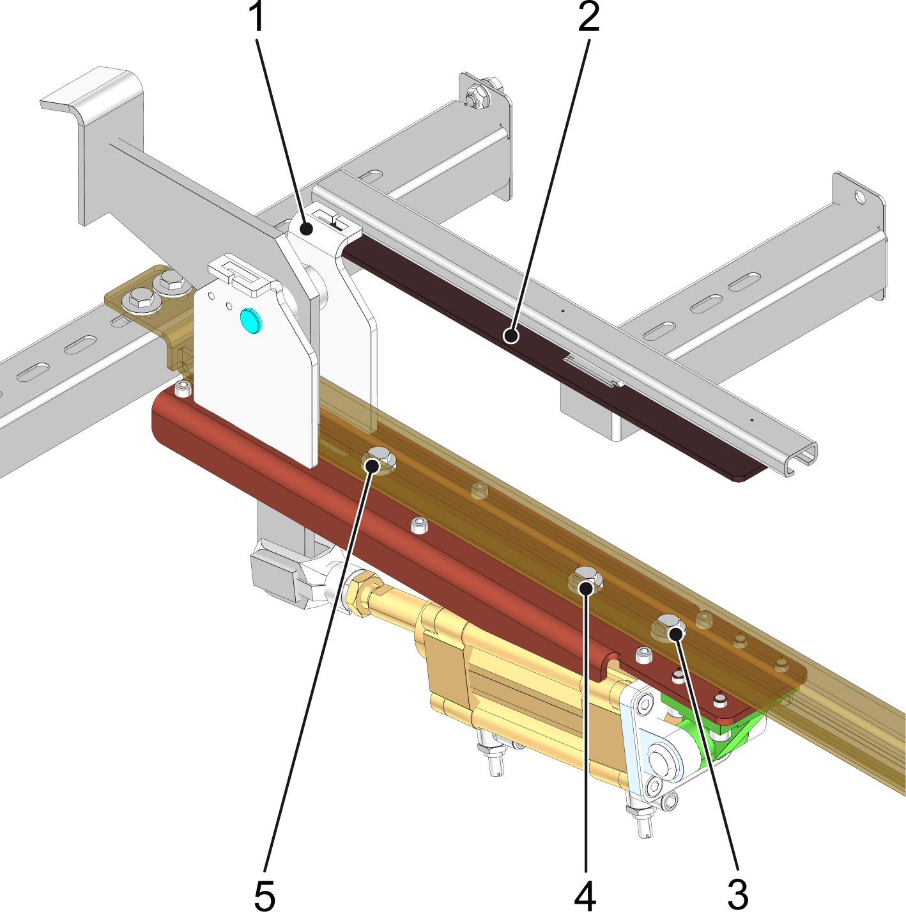

Figure 86: Setting up the pack barrier on the pack conveyor
- Indicator
- Scale
- Screw
- Screw
- Screw
Personnel:  Operating personnel
Prerequisites:
Production on the machine has ended.
- Enter the secured area through the safety door.
- Loosen the screws.
- Move the pack barrier together with the indicator to the scale dimension that is appropriate for the formation selected for pro‐ duction.
- Tighten the screws.
- Repeat steps 2 to 4 on all pack barriers in the machine area.

Setting up sensors on the pack conveyor
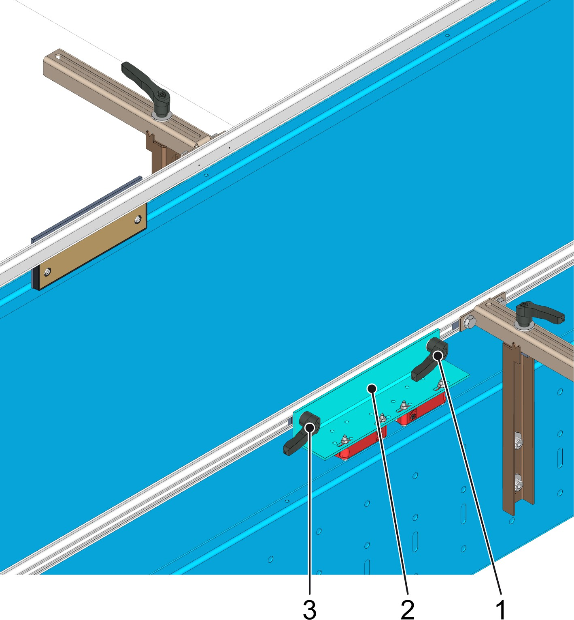

Figure 87: Setting up sensors on the pack conveyor
- Clamping lever
- Sensor
- Clamping lever
Personnel:  Operating personnel
Prerequisites:
Production on the machine has ended.
- Enter the secured area through the safety door.
- Release the clamping levers.
- Move the sensor to the scale dimension that is appropriate for the formation selected for production.
- Tighten the clamping lever.
- Repeat steps 2 to 4 on all sensors on the pack conveyor.

Setting up the rails on the pack conveyor
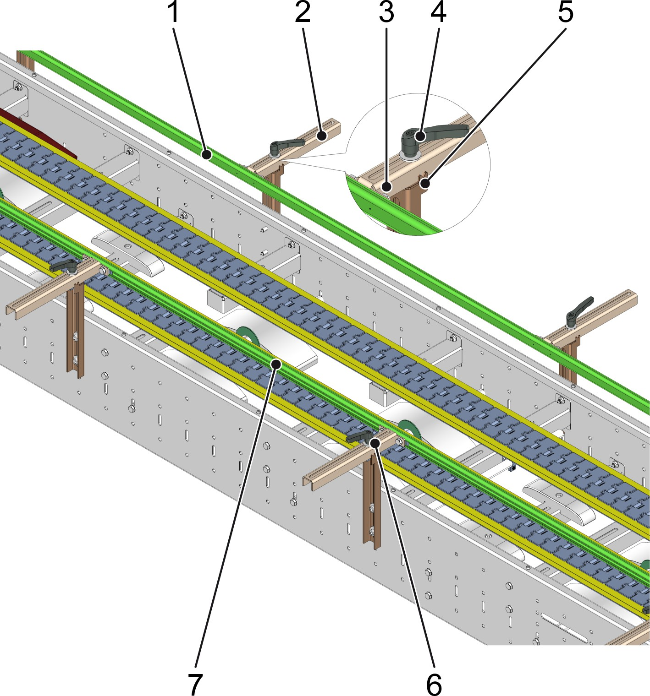

Figure 88: Setting up the rails on the pack conveyor
- Guide rails
- Guide rail mounts
- Scale
- Clamping lever
- Indicator
- Guide rail mounts
- Guide rails
Personnel:  Operating personnel
Prerequisites:
Production on the machine has ended.
- Enter the secured area through the safety door.
- Release the clamping levers on the guide rail mounts.
- Move the guide rails with the indicator of the guide rail mounts to the scale dimension that is appropriate for the formation selected for production.
- Tighten the clamping levers.

- Repeat steps 2 to 4 on all guide rail mounts in the machine area.

Setting up the rail guide on the container table
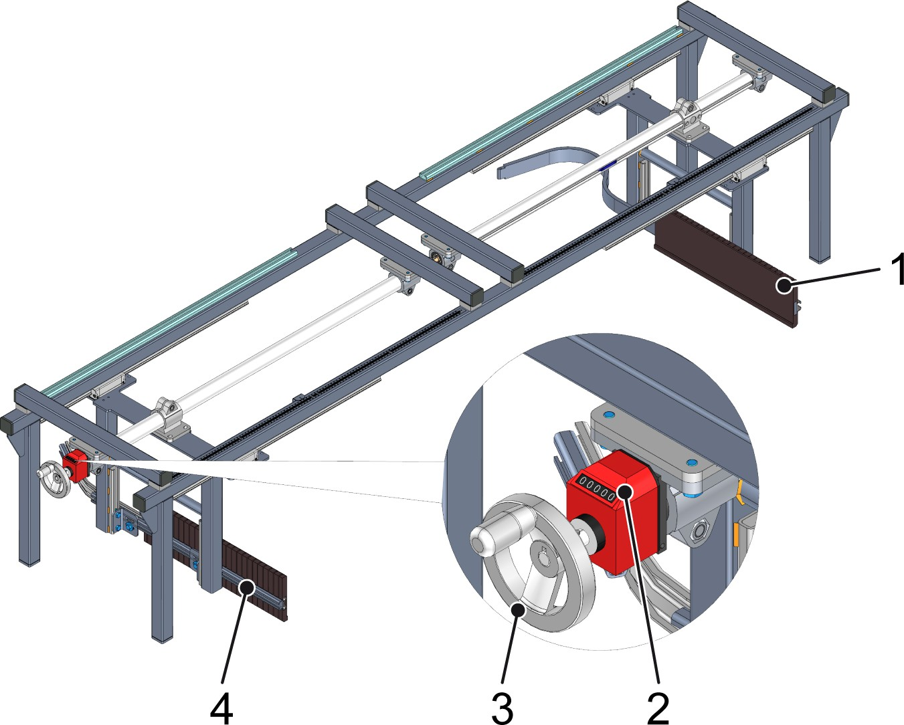

Figure 89: Setting up the rail guide on the container table
- Right guide rail
- Position indicator
- Handwheel
- Left guide rail
Personnel:  Operating personnel Prerequisites:
- The prerequisites for setup have been met.
- The format parts have been set up for the formation which has been selected for production.
- The machine has been run until empty and is at a standstill.
Turn the handwheel until the position indicator displays the value for the type that is to be set.
  - The guide rails have been adjusted to the position of the outer plates of the format part frame.

Setting up the hook stopper
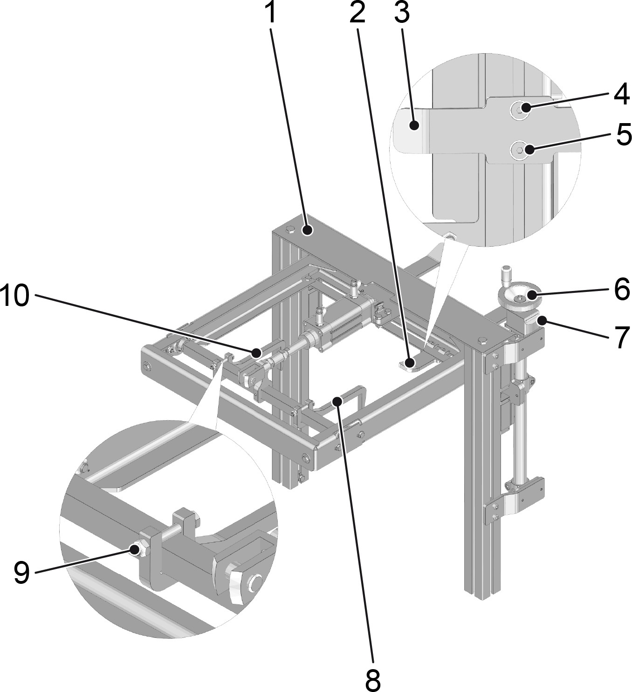

Figure 90: Setting up the hook stopper
- Hook stopper
- Pressure bracket
- Pressure bracket, view from below
- Screw on pressure bracket
- Screw on pressure bracket
- Turning spindle
- Counter
- Hook
- Screw on the fixture hook
- Hook
Following a type change, the hook stopper must be set up for the new dimensions. The height of the hook stopper is set by a turning spindle. The height is displayed by a mechanical counter. Turning forward or back increases or decreases the counter value.
Adjusting to the pack height
Personnel:  Operating personnel Requirement:

The machine is ready for setup.
Turn the turning spindle until the counter displays the number of rotations specified for the type.

Adjusting to the partition
Personnel:  Operating personnel
Requirement:
The packs for the selected formation have a different division to the previously conveyed type.
The machine is ready for setup.
- Undo the screws on the fixture hook.
- Move the hook to the dimensions appropriate for the selected formation.
- Tighten the screw.
- Repeat the procedure for all hooks on the hook stopper.

Se the width of the pressure bracket Personnel:  Operating personnel
Requirement:
The packs for the selected formation have a different width to the previously conveyed type.
The machine is ready for setup.
- Loosen the screws on the pressure bracket.
- Move the pressure bracket to the dimensions appropriate for the selected formation.
- Tighten the screws.
- Repeat the procedure for all pressure brackets on the hook stopper.

  - Taking the machine out of operation Personnel:  Operating personnel
- End production. See chapter “Operation”, section “Production”.
- Switch off the control voltage using the [Control voltage] key switch.
- Switch off the main switch and ensure that it cannot be switched back on.
- Close the main valve on the maintenance unit.

This page is left blank for editorial reasons.

